

Programme Name: ________**BCS HONS**_______________________________________

Course Code: __**STAT 1000**________

Course Name: ________**Introduction to Statistics**______________________________

_**Individual Project**___

Date of Submission: ______**4/10/2021**_____________

**Submitted By: Submitted To:**

Student Name**: Dipesh Tha Shrestha** Faculty Name**: Shanta Rayamajhi Basnet**

IUKL ID: **041902900028** Department**: LMS**

Semester**: Third Semester**

Intake**: September 2019**

**Report on Statistics**

**BY Dipesh Tha Shrestha**

**Context**

* 1. **Origin of Statistics**

**1.2 Definition of Statistics**

**1.3 Importance of statistics**

**1.4 Uses of Statistics**

**1.5 Scope of Statistics**

**1.6 Users of Statistics**

**1.7 Limitations of Statistics**

**1.8 Data (Variables)**

**1.9 Types of Data**

**Categorical: Nominal and Ordinal**

**Numerical: Individual, discrete and continuous**

**1.10 Pie chart**

**1.11 Bar diagram**

**1.12 Histogram**

**1.13 Frequency Polygon and Curve**

**1.14 Ogives**

**1.1 Origin of Statistics**

The word statistics is derived from the Latin word “status” or the Italian word “statista,” and meaning of these words is “political state” or “government.” Shakespeare used the word statist is his drama Hamlet (1602). In the past, statistics was used by rulers. The application of statistics was very limited, but rulers and kings needed information about land, agriculture, commerce, populations of their states to assess their military potential, their wealth, taxation and other aspects of government.

Gottfried Achenwall used the word statistik at a German university in 1749 to mean the political science of different countries. In 1771 W. Hooper (an Englishman) used the word statistics in his translation of Elements of Universal Erudition written by Baron B.F Bieford. In his book, statistics was defined as the science that teaches us the political arrangement of all the modern states of the known world. There is a big gap between the old statistics and modern statistics, but old statistics is also used as a part of present-day statistics.

During the 18th century, English writers used the word statistics in their works, so statistics has developed gradually during the last few centuries. A lot of work was done at the end of the nineteenth century.

At the beginning of the 20th century, William S Gosset developed the methods for decision making based on small sets of data. During the 20th century, several statisticians were active in developing new methods, theories and applications of statistics. These days, the availability of electronics is certainly a major factor in the modern development of statistics.

**1.2 Definition of Statistics**

Statistics, like many other sciences, is a developing discipline; it is not static. It has gradually developed during the last few centuries. Throughout history it has been defined in different manners. Some definitions from the past seem very strange today, but those definitions had their place in their own time. Defining a subject has always been a difficult task. A good definition from today may be discarded in the future. It is difficult to define statistics, and some of the definitions are discussed here.

The kings and rulers in ancient times were interested in their manpower. They conducted censuses of populations to gather data. They used this information to calculate their strength and ability for war. In those days, statistics was defined as:

“The science of kings, political and science of statecraft.”

A.L. Bowley defined statistics as:

“Statistics is the science of counting.”

This definition places the emphasis on counting only, and that common man considers statistics as nothing but counting. This used to be the situation a very long time ago; statistics today is not mere counting of people, counting of animals, counting of trees and counting of fighting forces. It has now developed into a rich method of data analysis and interpretation.

A.L. Bowley has also defined statistics as:

“The science of averages.”

This definition is very simple but it covers only some areas of statistics. Averages are very simple and important in statistics. Experts are interested in average deaths rates, average birth rates, average increases in population, average increases in per capita income, average increases in standard of living and cost of living, average development rates, average inflation rates, average production of rice per acre, average literacy rates and many other averages from different fields of practical life. But statistics is not limited to averages only; there are many other statistical tools like measures of variation, measures of correlation, measures of independence, etc. Thus, this definition is weak and incomplete and is no longer applicable.

Prof. Boddington has defined statistics as:

“The science of estimate and probabilities.”

This definition covers a major part of statistics, and is close to modern statistics. But it is not complete because it stresses only probability. There are some areas of statistics in which probability is not used.

**1.3 Importance of statistics**

Statistics plays a vital role in every field of human activity. Statistics helps in determining the existing position of per capita income, unemployment, population growth rates, housing, schooling medical facilities, etc., in a country.

Now statistics holds a central position in almost every field, including industry, commerce, trade, physics, chemistry, economics, mathematics, biology, botany, psychology, astronomy, etc., so the application of statistics is very wide. Now we shall discuss some important fields in which statistics is commonly applied.

1. **Business**

Statistics plays an important role in business. A successful businessman must be very quick and accurate in decision making. He knows what his customers want; he should therefore know what to produce and sell and in what quantities.

Statistics helps businessmen to plan production according to the taste of the customers, and the quality of the products can also be checked more efficiently by using statistical methods. Thus, it can be seen that all business activities are based on statistical information. Businessmen can make correct decisions about the location of business, marketing of the products, financial resources, etc.

1. **Economics**

 Economics largely depends upon statistics. National income accounts are multipurpose indicators for economists and administrators, and statistical methods are used to prepare these accounts. In economics research, statistical methods are used to collect and analyze the data and test hypotheses. The relationship between supply and demand is studied by statistical methods; imports and exports, inflation rates, and per capita income are problems which require a good knowledge of statistics.

1. **Mathematics**

Statistics plays a central role in almost all natural and social sciences. The methods used in natural sciences are the most reliable but conclusions drawn from them are only probable because they are based on incomplete evidence.

Statistics helps in describing these measurements more precisely. Statistics is a branch of applied mathematics. A large number of statistical methods like probability averages, dispersions, estimation, etc., is used in mathematics, and different techniques of pure mathematics like integration, differentiation and algebra are used in statistics.

1. **Banking**

Statistics plays an important role in banking. Banks make use of statistics for a number of purposes. They work on the principle that everyone who deposits their money with the banks does not withdraw it at the same time. The bank earns profits out of these deposits by lending it to others on interest. Bankers use statistical approaches based on probability to estimate the number of deposits and their claims for a certain day.

1. **State Management (Administration)**

Statistics is essential to a country. Different governmental policies are based on statistics. Statistical data are now widely used in making all administrative decisions. Suppose if the government wants to revise the pay scales of employees in view of an increase in the cost of living, and statistical methods will be used to determine the rise in the cost of living. The preparation of federal and provincial government budgets mainly depends upon statistics because it helps in estimating the expected expenditures and revenue from different sources. So statistics are the eyes of the administration of the state.

1. **Accounting and Auditing**

Accounting is impossible without exactness. But for decision making purposes, so much precision is not essential; the decision may be made on the basis of approximation, know as statistics. The correction of the values of current assets is made on the basis of the purchasing power of money or its current value.

In auditing, sampling techniques are commonly used. An auditor determines the sample size to be audited on the basis of error.

1. **Natural and Social Sciences**

Statistics plays a vital role in almost all the natural and social sciences. Statistical methods are commonly used for analyzing experiments results, and testing their significance in biology, physics, chemistry, mathematics, meteorology, research, chambers of commerce, sociology, business, public administration, communications and information technology, etc.

1. **Astronomy**

Astronomy is one of the oldest branches of statistical study; it deals with the measurement of distance, and sizes, masses and densities of heavenly bodies by means of observations. During these measurements errors are unavoidable, so the most probable measurements are found by using statistical methods.

Example: This distance of the moon from the earth is measured. Since history, astronomers have been using statistical methods like method of least squares to find the movements of stars.

**1.4 Uses of Statistics**

Uses of Statistics are given below:

1. Statistics helps in providing a better understanding and accurate description of nature’s phenomena.
2. Statistics helps in the proper and efficient planning of a statistical inquiry in any field of study.
3. Statistics helps in collecting appropriate quantitative data.
4. Statistics helps in presenting complex data in a suitable tabular, diagrammatic and graphic form for an easy and clear comprehension of the data.
5. Statistics helps in understanding the nature and pattern of variability of a phenomenon through quantitative observations.
6. Statistics helps in drawing valid inferences, along with a measure of their reliability about the population parameters from the sample data.

**1.5 Scope of Statistics**

Statistics has become as wide as to include in its fold all quantitative studies and analysis relating to any department of enquiry. This, indeed, give the science of Statistics a very wide scope and one would thing that Statistics has almost an unlimited scope.

The chief importance of Statistics lies in providing the quantitative measurement to a phenomenon. Lord Kelvin rightly says, “when you can measure what you are speaking about and express it in numbers, you know something about it, but when you cannot measure it, when you cannot express it in numbers your knowledge is of a meager and unsatisfactory kind”. Quantitative measurement is the sign of the growth of particular discipline and our knowledge and control over the phenomenon. We are no longer satisfied by casual remark that the prices are rising, we must know how much they have risen. This we can do my means of index numbers of prices. It will no longer satisfy us to say that India has economically improved since independence. We would like to have exact measurement. This can be provided by figures of national income and per capital income.

Quantification of social phenomena is the basis of objective observation. Qualitative description is by nature haphazard, not standard and subjective. If two persons are asked to comment about the standard of living of a person, they are very likely to give different opinions. This can be avoided only when we have found out an exact measurement of the standard of living. Similarly, if intelligence of boys were to be expressed in the qualitative terms it would not give a clear picture to us. But if the same were to be expressed in terms of examination marks or I.Q. there will be no difficulty in understanding it and also there will not be variety of opinions about it.

Statistical analysis brings greater precision to our thinking. When facts are reduced to arithmetical figures all argument comes to an end and conclusion can be challenged only by counter Statistics. Figures never lie. They will put plain facts in the coldest and most detached way whatever may be the outcome.

As we are moving more towards social planning we have to base our policy upon aggregative figures. This is not much of consequence whether a person has committed suicide under some strange circumstances, what is important for social planners are the fact whether there has been a fall in the number of suicides. We can never remove suicides from the society. What is of consequence is therefore, whether the number of crimes and their seriousness in increasing or decreasing. Despite of our best efforts the accidents must occur. We as social planners are mainly concerned whether the accidents have shown a declining tendency.

Statistics is equally important in the evaluation of social reforms and nature and extent of social evils. Nothing can give clearer picture of the evil of drinking than the figures regarding the cases of suicides, indebtedness, high death rate and incidence of disease in the families of those who are drunkards. Similarly, the usefulness of prohibition can also be judged by the facts.

Statistical methods are becoming more and more popular among the social sciences. Successful attempts have been made at providing standard quantitative measures of phenomena which ahs hitherto remained qualitative in nature. We are moving more towards perfection and precision with the use of these refined tools of analysis.

**1.6 Users of Statistics**

The Institutional users include European organisations, such as the European Parliament and Council, European Economic and Social Committee, European Central Bank, Committee of the Regions, European Statistical System Committee, European Trade Union Confederation, Confederation of European Business, European Data Protection Supervisor, and the European Association of Craft, Small and medium-sized Enterprises. As underlined by Lamel (2002) Article 1 of Regulation (EC) No 322/97 establishes a legislative framework for the systematic and programmed production of Community statistics. Hence the policies of the Community determine what European-level statistics should cover, and the EU Institutions that are the main users.

Non-institutional users, individuals belonging or not to institutions, include the following groups, according to their interest on statistics:

1. Users with a general interest (e.g., economic growth)
   * Journalists and media
   * Citizens
   * Students (by level of education, or age) and Teachers (by level of teaching education)
2. Users with a specific subject/domain interest (e.g., health)
   * Other decision makers
   * Policy analysts
   * Marketing analysts
   * Experts in a specific field

3. Users with a research interest (e.g., innovation in enterprises)

* + Scientific community – academics and researchers at universities and research institutions
  + Consultants and researchers in Governmental Agencies and private sector

**1.7 Limitations of Statistics**

Like other sciences, statistics also has its limitations. They are as follows:

1. **Unable to express quantitatively:**

Statistics cannot be applied to those facts which are not capable of being quantitatively expressed. Such facts should first be reduced to precise quantitative terms. For example, we cannot compare ‘culture’ of two countries unless we specify by ‘culture’ of two countries unless we specify by culture so many industries, hospitals, educational institutions, places of worship, law courts, etc. Statistical studies cannot be brought to bear upon such phenomena unless we express them in definite mathematical quantities. Similarly, it is not possible to study ‘prosperity’, ‘intelligence’, ‘honesty’, ‘youth’ etc., unless we specify them as standing for certain requisite quantitative standards

1. **Not applicable to studies of individuals:**

Statistics does not take cognizance of individual items because they are aggregates of facts. It is unimportant as to what are the marks secured by a student in a certain class test, unless we know the marks of all the students and draw conclusions on that basis. Marks of one student do not constitute statistics, because one of the characteristics of Statistics is that they should be capable of being placed in relation to each other. Individual items cannot be placed in such a relationship

1. **Statistical laws are true only on an average and in the long run:**

The quantitative nature of Statistics is true only on an average and in the long run. For example, the theory of probability says that if we toss a coin twice, one time it may fall head upward and a second time head downward. But it is possible that both the times it may come head upward or head downward. This possibility of 50 per cent times heads upward and 50 per cent times head downward will be approximately true if this experiment is repeated a larger number of times.

1. **Statistics often leads to false conclusions:**

Statistics often leads to false conclusions, generally, in cases where Statistics are quoted without context or details. For example, in a certain competitive examination in the subject Computers the students of Andhra University have done better than those of Osmania University, it does not mean that the former University has a better standard. It is possible that the students of Andhra University may have been trained in special course in Computers while those of Osmania University may not have enjoyed such facility.

1. **Uniform data always not possible:**

The statistical data must be uniform and its main characteristics must be stable throughout the study. It is not possible to compare the wages in two factories if the average wage is composed of adult wages in one, and of the wages of adults and children in the other. The data must be highly uniform and homogeneous.

1. **Only one among various methods:**

Statistical methods are not the only method of finding the value of a group. There are other methods of studying a problem besides statistics.

1. **Wrong handling:**

Statistics must always be handled by experts; otherwise, they give wrong results.

**1.8 Data (Variables)**

Data refers to a set of values, which are usually organized by variables (what is being measured) and observational units (members of the sample/population). An example of data is a data matrix in a spreadsheet program, such as Excel or SPSS. Along the upper horizontal line there are the variables (e.g. survey questions) and down the first vertical line there are the observations (e.g. people). In each cell there is a value that is the given observational unit’s value of a given variable. Variables are of different types and can be classified in many ways, for example as numerical and categorical variables. Numerical variables are measured by some (usually existing) measures, whereas categorical variables are qualitative, and not necessarily more or less, or bigger and smaller than one another. Another way of classifying variables is according to their measurement scale. A variable is any characteristics, number, or quantity that can be measured or counted. A variable may also be called a data item. Age, sex, business income and expenses, country of birth, capital expenditure, class grades, eye colour and vehicle type are examples of variables. It is called a variable because the value may vary between data units in a population, and may change in value over time.  
  
For example; 'income' is a variable that can vary between data units in a population (i.e. the people or businesses being studied may not have the same incomes) and can also vary over time for each data unit (i.e. income can go up or down).

**1.9 Types of Data**

**Categorical: Nominal and Ordinal**

**Numerical: Individual, discrete and continuous**

* **Categorical Data**

Categorical data represents characteristics. Therefore it can represent things like a person’s gender, language etc. Categorical data can also take on numerical values (Example: 1 for female and 0 for male). Note that those numbers don’t have mathematical meaning.

* **Nominal Data**

Nominal values represent discrete units and are used to label variables, that have no quantitative value. Just think of them as „labels“. Note that nominal data that has no order. Therefore if you would change the order of its values, the meaning would not change. You can see two examples of nominal features below:

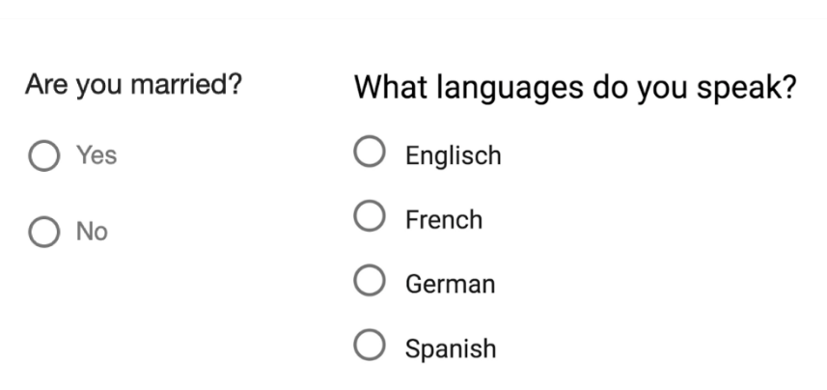

The left feature that describes if a person is married would be called „dichotomous“, which is a type of nominal scales that contains only two categories.

* **Ordinal Data**

Ordinal values represent discrete and ordered units. It is therefore nearly the same as nominal data, except that it’s ordering matters. You can see an example below:

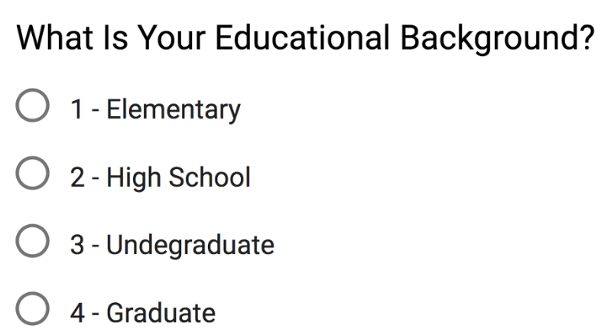

Note that the difference between Elementary and High School is different than the difference between High School and College. This is the main limitation of ordinal data, the differences between the values is not really known. Because of that, ordinal scales are usually used to measure non-numeric features like happiness, customer satisfaction and so on.

* **Numerical Data**
* **Individual Data**

Collected data which can be associated with a single element in a sample are called individual data.

An example: all data that result from responses from John Doe are individual data. The totality of all data collected in a survey is combined into aggregated data in order to be evaluated. Only with access to individual data can we make meaningful calculations in descriptive and inductive statistics.

* **Discrete Data**

We speak of discrete data if its values are distinct and separate. In other words: We speak of discrete data if the data can only take on certain values. This type of data **can’t be measured but it can be counted**. It basically represents information that can be categorized into a classification. An example is the number of heads in 100 coin flips.

You can check by asking the following two questions whether you are dealing with discrete data or not: Can you count it and can it be divided up into smaller and smaller parts?

* **Continuous Data**

Continuous Data represents measurements and therefore their values **can’t be counted but they can be measured**. An example would be the height of a person, which you can describe by using intervals on the real number line.

**1.10 Pie chart**

The “**pie chart”** also is known as “circle chart”, that divides the circular statistical graphic into sectors or slices in order to illustrate the numerical problems. Each sector denotes a proportionate part of the whole. To find out the composition of something, Pie-chart works the best at that time. In most of the cases, pie charts replace some other graphs like the bar graph, line plots, histograms etc.

The pie chart is an important type of data representation. It contains different segments and sectors in which each segment and sectors of a pie chart forms a certain portion of the total(percentage). The total of all the data is equal to 360°.

**The total value of the pie is always 100%.**

To work out with the percentage for a pie chart, follow the steps given below:

* Categorize the data
* Calculate the total
* Divide the categories
* Convert into percentages
* Finally, calculate the degrees

Therefore, the pie chart formula is given as

**(Given Data/Total value of Data) × 360°**

**Advantages**

* The picture is simple and easy-to-understand
* Data can be represented visually as a fractional part of a whole
* It helps in providing an effective communication tool for the even uninformed audience
* Provides a data comparison for the audience at a glance to give an immediate analysis or to quickly understand information
* No need for readers to examine or measure underlying numbers themselves which can be removed by using this chart
* To emphasize a few points you want to make, you can manipulate pieces of data in the pie chart

**Disadvantages**

* It becomes less effective, if there are too many pieces of data to use
* If there are too many pieces of data, and even if you add data labels and numbers may not help here, they themselves may become crowded and hard to read
* As this chart only represents one data set, you need a series to compare multiple sets
* This may make it more difficult for readers when it comes to analyze and assimilate information quickly

**Example** **of Pie-Chart**

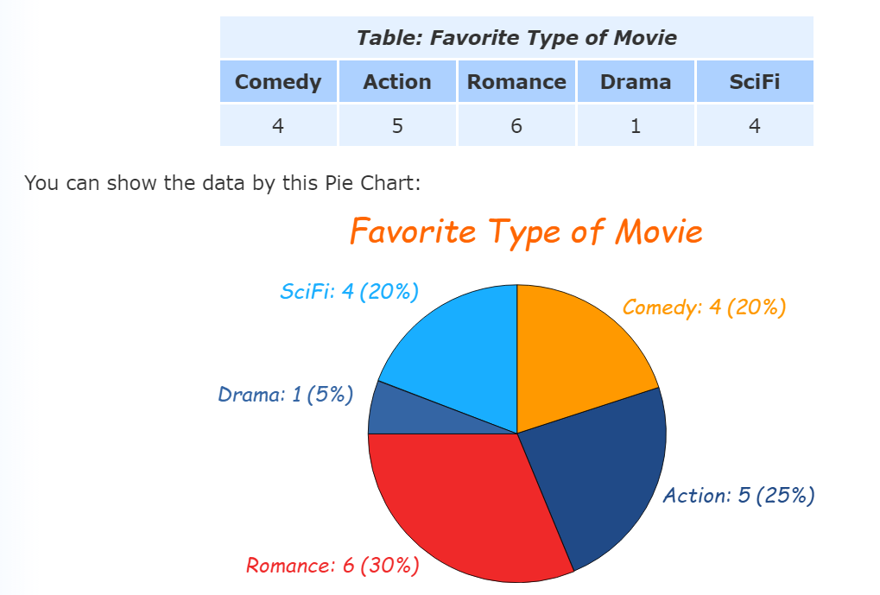

**1.11 Bar diagram**

A bar graph (diagram) is a pictorial representation of the data by a series of bars or rectangles of uniform width standing on the same horizontal (or vertical) base line with equal spacing between the bars. Each rectangle or bar represents only one numerical value of the data. The height (or length in case the base is on a vertical line) of each bar is proportional to the numerical values of the data. The pictorial representation of a grouped data, in the form of vertical or horizontal rectangular bars, where the lengths of the bars are equivalent to the measure of data, are known as bar graphs or bar charts.

The bars drawn are of uniform width, and the variable quantity is represented on one of the axes. Also, the measure of the variable is depicted on the other axes. The heights or the lengths of the bars denote the value of the variable, and these graphs are also used to compare certain quantities. The frequency distribution tables can be easily represented using bar charts which simplify the calculations and understanding of data.

The three major attributes of bar graphs are:

* The bar graph helps to compare the different sets of data among different groups easily.
* It shows the relationship using two axes, in which the categories on one axis and the discrete values on the other axis.
* The graph shows the major changes in data over time.

For example, we are given a data about the household expenditure of a family as below :

|  |  |
| --- | --- |
| Heads of expenditure | Expenditure  (in thousand rupees) |
| Rent | 5 |
| Grocery | 2 |
| Education | 3 |
| Transport | 2 |
| Miscellaneous | 4 |

We draw the bar graph for the above data as below:  
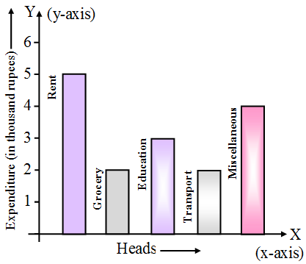  
The horizontal axis is generally called x-axis and the vertical axis as the y-axis.

* Each bar of a bar diagram has same width.
* Space between two consecutive bars is same throughout.

**1.12 Histogram**

A histogram is a graphical representation that organizes a group of data points into user-specified ranges. Similar in appearance to a bar graph, the histogram condenses a data series into an easily interpreted visual by taking many data points and grouping them into logical ranges or bins. A histogram is used to summarize discrete or continuous data. In other words, it provides a visual interpretation of numerical data by showing the number of data points that fall within a specified range of values (called “bins”). It is similar to a vertical bar graph. However, a histogram, unlike a vertical bar graph, shows no gaps between the bars.

**Example of a Histogram**

Jeff is the branch manager at a local bank. Recently, Jeff’s been receiving customer feedback saying that the wait times for a client to be served by a customer service representative are too long. Jeff decides to observe and write down the time spent by each customer on waiting. Here are his findings from observing and writing down the wait times spent by 20 customers:

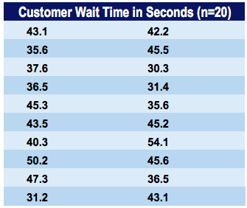

The corresponding histogram with 5-second bins (5-second intervals) would look as follows:

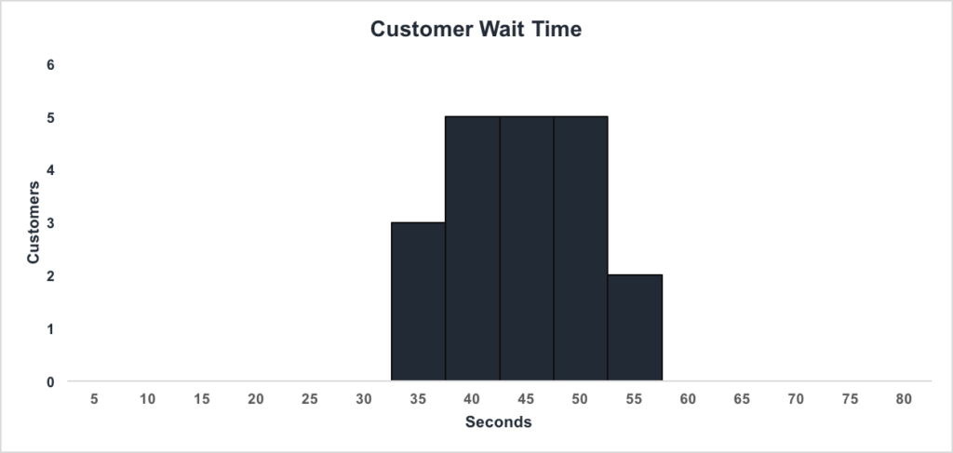

We can see that:

* There are **3 customers**waiting between **1 and 35 seconds**
* There are **5 customers**waiting between **1 and 40 seconds**
* There are **5 customers** waiting between **1 and 45 seconds**
* There are **5 customers** waiting between **1 and 50 seconds**
* There are **2 customers**waiting between **1 and 55 seconds**

Jeff can conclude that the majority of customers wait between 35.1 and 50 seconds.

**1.13 Frequency Polygon and Curve**

A frequency polygon is almost identical to a histogram, which is used to compare sets of data or to display a cumulative frequency distribution. It uses a line graph to represent quantitative data.

Statistics deals with the collection of data and information for a particular purpose. The tabulation of each run for each ball in cricket gives the statistics of the game. Tables, graphs, pie-charts, bar graphs, histograms, polygons etc. are used to represent statistical data pictorially.

Frequency polygons are a visually substantial method of representing quantitative data and its frequencies. Let us discuss how to represent a frequency polygon.

**Steps to Draw Frequency Polygon**

To draw frequency polygons, first we need to draw histogram and then follow the below steps:

**Step 1-** Choose the class interval and mark the values on the horizontal axes

**Step 2-** Mark the mid value of each interval on the horizontal axes.

**Step 3-** Mark the frequency of the class on the vertical axes.

**Step 4-** Corresponding to the frequency of each class interval, mark a point at the height in the middle of the class interval

**Step 5-** Connect these points using the line segment.

**Step 6-** The obtained representation is a frequency polygon.

Let us consider an example to understand this in a better way.

**Example**

**In a batch of 400 students, the height of students is given in the following table. Represent it through a frequency polygon.**

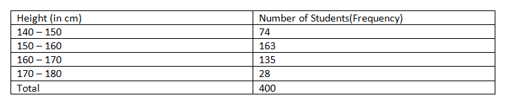

**Solution:** Following steps are to be followed to construct a histogram from the given data:

The heights are represented on the horizontal axes on a suitable scale as shown.

The number of students is represented on the vertical axes on a suitable scale as shown.

Now rectangular bars of widths equal to the class- size and the length of the bars corresponding to a frequency of the class interval is drawn.

ABCDEF represents the given data graphically in form of frequency polygon as:

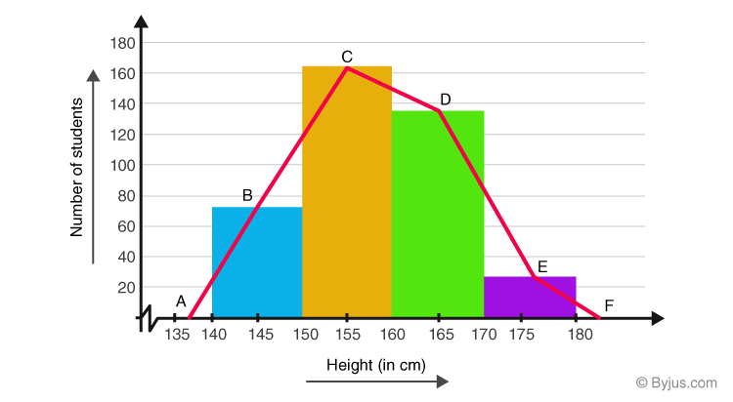

Frequency polygons can also be drawn independently without drawing histograms. For this, the midpoints of the class intervals known as class marks are used to plot the points.

Frequency Polygons

**Frequency curve** is a smooth and free-hand curve drawn to represent a frequency distribution. Frequency curve is drawn by smoothing the vertices of the frequency polygon. Frequency curve provides better understanding about the properties of the data than frequency polygon and histogram.

**Example**

The ages of group of pensioners are given in the table below. Draw the Frequency curve to the following data.

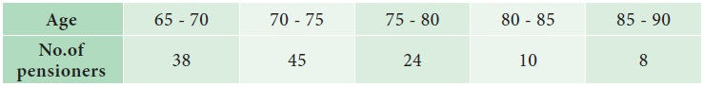

**Solution:**

Since we are displaying the distribution of Age and Number of Pensioners, the Frequency curve is drawn, to provide better understanding about the age and number of pensioners than frequency polygon.

The following procedure can be followed to draw frequency curve:

Step 1: Age are marked along the X-axis and labeled as ‘Age’.

Step 2: Number of pensioners are marked along the Y-axis and labeled as ‘No. of Pensioners’.

Step3: Mark the midpoints at the top of each vertical bar in the histogram representing the age.

Step 4: Connect the midpoints by line segments by smoothing the vertices of the frequency polygon

The Frequency curve is presented in Fig

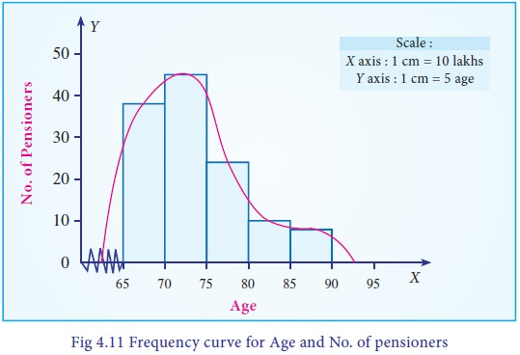

**1.14 Ogives**

Cumulative frequency curve (Ogive) is drawn to represent the cumulative frequency distribution. There are two types of Ogives such as ‘less than Ogive curve’ and ‘more than Ogive curve’. To draw these curves, we have to calculate the ‘less than’ cumulative frequencies and ‘more than’ cumulative frequencies. The following procedure can be followed to draw the ogive curves:

Less than Ogive: Less than cumulative frequency of each class is marked against the corresponding upper limit of the respective class. All the points are joined by a free-hand curve to draw the less than ogive curve.

More than Ogive: More than cumulative frequency of each class is marked against the corresponding lower limit of the respective class. All the points are joined by a free-hand curve to draw the more than ogive curve.

Both the curves can be drawn separately or in the same graph. If both the curves are drawn in the same graph, then the value of abscissa (x-coordinate) in the point of intersection is the median.

If the curves are drawn separately, median can be calculated as follows:

Draw a line perpendicular to Y-axis at y=N/2. Let it meet the Ogive at C. Then, draw a perpendicular line to X-axis from the point C. Let it meet the X-axis at M. The abscissa of M is the median of the data.

**Example**

Draw the less than Ogive curve for the following data:

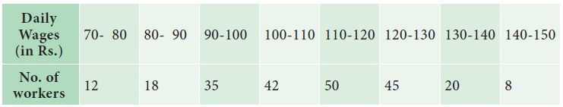

**Solution:**

Since we are displaying the distribution of Daily Wages and No. of workers, the Ogive curve is drawn, to provide better understanding about the wages and No. of workers.

The following procedure can be followed to draw Less than Ogive curve:

Step 1 : Daily wages are marked along the X-axis and labeled as “Wages(in `)”.

Step 2 : No. of Workers are marked along the Y-axis and labeled as “No. of workers”.

Step 3 : Find the less than cumulative frequency, by taking the upper class-limit of daily wages. The cumulative frequency corresponding to any upper class-limit of daily wages is the sum of all the frequencies less than the limit of daily wages.

Step 4 : The less than cumulative frequency of Number of workers are plotted as points against the daily wages (upper-limit). These points are joined to form less than ogive curve.

The Less than Ogive curve is presented in Fig

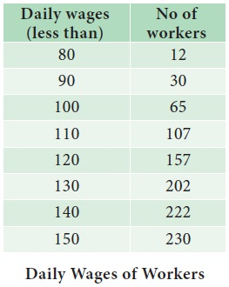

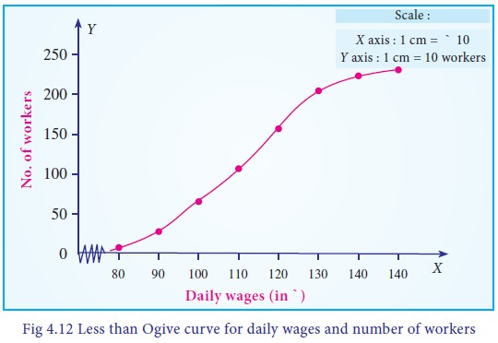

Thank You